**Concordium’s Innovative Identity Layer Framework.**



In contrast to antecedent blockchain architectures that lack true transactional anonymity, and absence of mechanism for discerning the real-world identity of potentially suspicious users, Concordium introduces an innovative identity layer. This pioneering identity layer aims to surmount challenges in the adoption of blockchain technologies within regulatory frameworks. Striking a delicate balance between user privacy and accountability, the identity layer enables authorized entities, under reasonable suspicion, to ascertain a user’s real-world identity and scrutinize their transactional history. This process is facilitated through anonymity revokers and identity providers, mirroring established practices in conventional financial institutions.

There are three entities within the Identity layer:

**Account Holders (Users):**

These are Individuals or entities seeking to create accounts and conduct transactions on the Concordium blockchain. Registration with an identity provider is a prerequisite before on-chain account creation.

**Identity Providers:**

An identity provider is an organization endorsed by Concordium entity tasked with executing off-chain identification procedures for users within the Concordium blockchain ecosystem. The first steps for Concordium account creation involve obtaining a verified identity from an identity provider.

During the identification process, an identity provider authenticates various user attributes, including the individual’s name or passport number. Upon successful verification of this information, the identity provider issues an identity object encapsulating user details structured within an ID schema.

Information supporting an ID verification, used prior to issuance of the identity is exclusively retained within the off-chain records of the identity providers, ensuring the establishment of a secure and reliable process for acquiring verified identities, aligning to Concordium’s commitment to robust security measures and regulatory compliance.

The Primary functions of identity providers include:

· User identity verification,

· Issuance of identity certificates

· Creation and storage of identity objects, and

· Participation in the anonymity revocation process.

Information about Concordium’s approved identity providers such as their name, location or public key, is found in an on-chain registry.

**Anonymity Revokers:**

An anonymity revoker within the Concordium Platform is an entrusted individual or entity designated to assist in the identification of a user holding an account. Operating as a pivotal interface between regulatory authorities and users within the Concordium blockchain ecosystem, anonymity revokers act upon court orders mandating the disclosure of comprehensive information conducive to unveiling specific user identities.

Within the Concordium Platform, all user accounts are intricately tied to real-world identities, interlinked with identity objects securely stored by endorsed identity providers. Identity objects are further associated with a specific set of anonymity revokers.

The critical role of anonymity revokers materializes in the exposure of the real-world identity of a potentially suspicious user. This is achieved through the decryption of the distinctive user identifier securely stored on-chain for each account. Disclosure of identities usually involves legal process where the requester serves two court orders to the identity provider, after which the identity of the user can be revealed on the second court order. This process varies according to country.

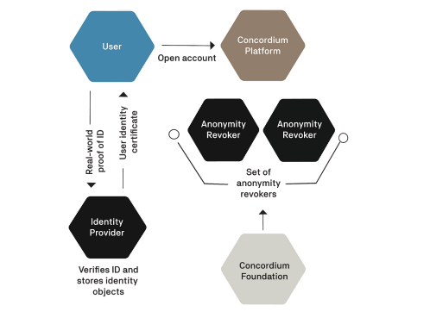

***The Anonymity Revoking Process.***

In Conclusion, The Concordium identity layer thus establishes a comprehensive and secure framework, aligning with regulatory requirements while preserving user privacy. The orchestrated interplay between account holders, identity providers, and anonymity revokers ensures a robust mechanism for identity verification, accountability, and compliance within the Concordium blockchain ecosystem.